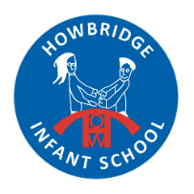
Welcome to Reception
September 2024
We would like to wish you a warm welcome to Early Years Foundation Stage (EYFS) at Howbridge Infant School. Here is some information to help you for the coming year.
Meet the Team
Primrose Class  (Class 7) | Bluebell Class  (Class 8) | Snowdrop Class  (Class 9)
Class Teachers  Mrs Ward (Mon-Weds) & Mrs Coyne (Weds-Fri)  Teaching Assistant  Miss Scrivener | Class Teacher  Mrs Pickess  Teaching Assistant  Mrs Hurricks | Class Teacher  Miss Banks  Teaching Assistant  Mrs Hine
Our Adventure Begins…
Our topic for the autumn term is called ‘Our Adventure Begins’. We will be spending time settling into school and getting to know each other. We have lots of exciting and fun activities planned for the children to give them a range of experiences where they can learn through play. Some of these will be familiar and linked to their interests and others brand new. We will be sharing the children’s experiences with you through the online platform ‘Tapestry’. You will be receiving your activation email for this over the next week and if you do not please speak to your child’s class teacher. We have a number of parent workshops planned over the term, the first being our Welcome Meeting which is being held in the hall on Wednesday 11th September at 2:45pm. We will be telling you more about our curriculum and what we are working towards at the end of this year. We are very excited to start the new school year with you and your child, and working together to ensure that your child is happy and thrives during their first year at school.

What your child needs
Please ensure your child brings their water bottle, reading folder, water proof coat and sun hat with them each day. They will also need a pair of wellington boots in school. PE kits are to remain in school as they will be used regularly throughout the week. It would also be helpful for your child to have spare underwear (just in case!). Children will be provided with a healthy snack each day. PLEASE ENSURE THAT EVERYTHING IS NAMED CLEARLY

Reading at Home
The children have chosen their first reading corner book today and have their own reading diary. These are for you to record any reading or story sharing you do with your child at home. For each day that your child reads at home and you have signed their reading record they will move their name along our class bookworm. Each time that they reach the top of the bookworm they will achieve a special certificate.


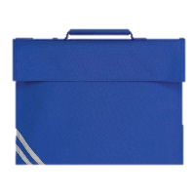
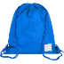


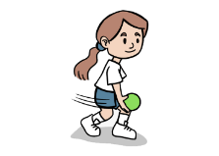
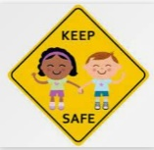
Drop off and Collection
Children are to be dropped off at their classroom door between 8:40am and 8:55am. School finishes at 3:10pm. Children who are late will need to report to the office. If someone different is collecting your child please let your class teacher know. Please be aware that anyone collecting your child must be over the age of 14.
Health & Safety
We are learning through play both inside and outside the classroom all of the time!
Please help to keep your child safe by ensuring that they do not wear jewellery to school, this includes earrings. We are not able to accept ‘taped’ piercings.
If any of your child’s details change, including medical information or your contact details then please let the school office know as soon as possible.

PE
Reception will have PE on a:
Thursday
Lessons will be led by class teachers and our Sports Coach Mr Potter. Children will need to bring outdoor kits including trainers, navy jumpers and jogging bottoms as well as their white t-shirt, shorts and socks. This kit will need to stay in school and be named.






Contact
Please have a look at our school website as there is lots of information available for you:
https://howbridge-inf.essex.sch.uk/

If you have any further questions you can contact the office via phone or email.
admin@howbridge-inf.essex.sch.uk

If you have any questions about learning please do not hesitate to speak to your child’s class teacher or you can message the Reception Team via your child’s Tapestry account. We will endeavour to respond within 2 working days.

