
Year 2 End of Year Expectations
Year 2 End of Year National Expectations 2024-2025

This booklet contains information about the national expectations for year 2 children by the end of year 2.
These are the current expectations of attainment by the end of Year 2 as stated in the National Curriculum. These statements are introduced and revisited throughout the year in a variety of contexts.
Your child will be working on these objectives throughout the year and we will keep you up to date with the progress they are making.
Please remember not all children will reach the same point by the end of the year. So what is most important is the amount of progress your child makes during the year in order to reach their potential and the targets we have set.
We hope you find the attached information useful. Please ask if you have any questions.

Phonics Screening Checks 2025
If your child did not meet the expected standard during the Phonics Screening Check in Year 1, they will sit the National Phonics Screening check during the week beginning 9th June 2025.

Reading
These are the current expectations of attainment by the end of Year 2. These statements are introduced and revisited throughout the year, in a variety of contexts.
This booklet contains information about what is expected of your child throughout year 2, and the expected level we are working towards for the end of the year.
Year 2 End of Year Expectations

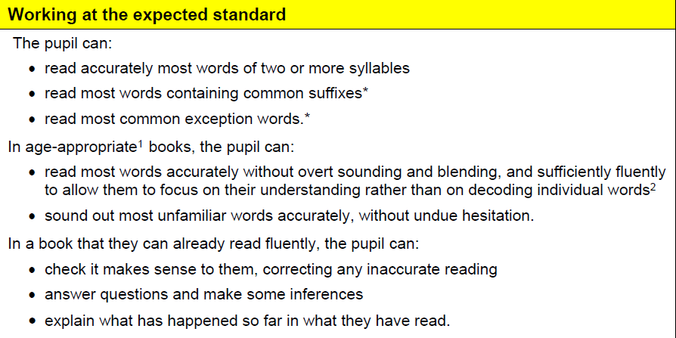
Reading

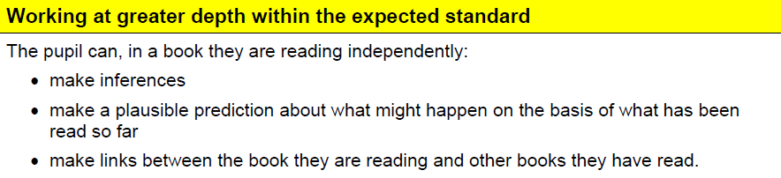

These are Year 2 Common Exception Words. Children are expected to read these words fluently, and spell them without support.

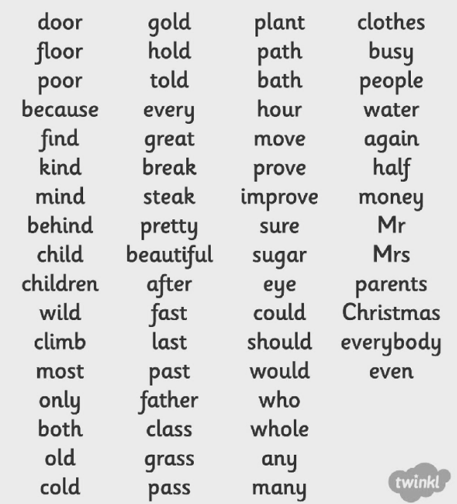

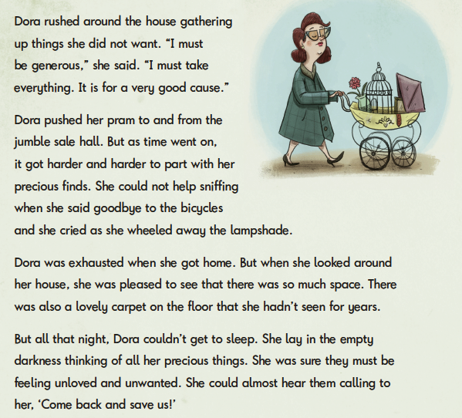
Here is an example of a text a year 2 expected level child should be able to read by the end of the year.

In Year 2, children are then expected to be able to answer questions based on the text they have read. They may need to make inferences and deductions or look for information written in the text.

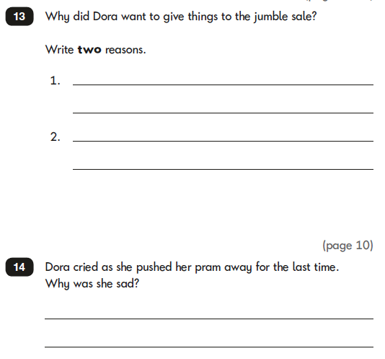

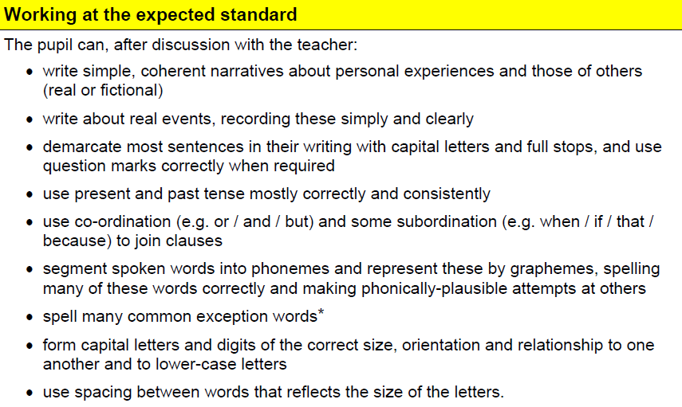
Writing

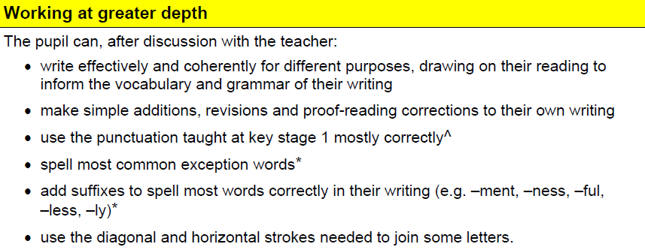

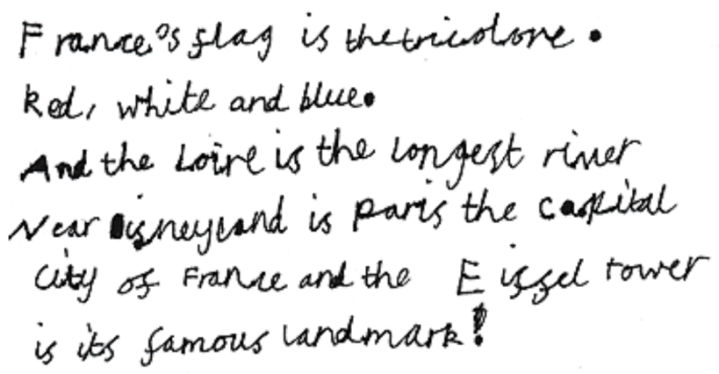
Handwriting expectations for the end of Year 2

In Year 2 all children are expected to join their handwriting.

Spelling and composition expectations for the end of Year 2

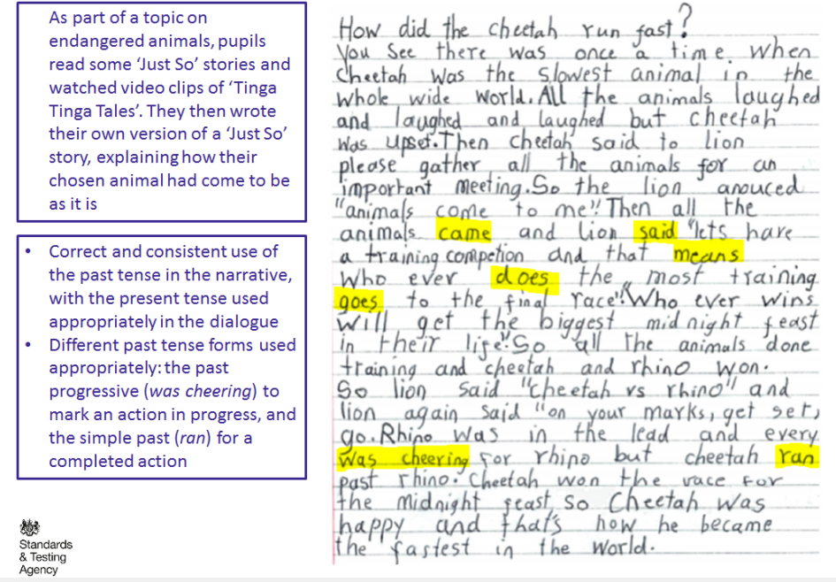

Vocabulary and punctuation expectations for the end of Year 2
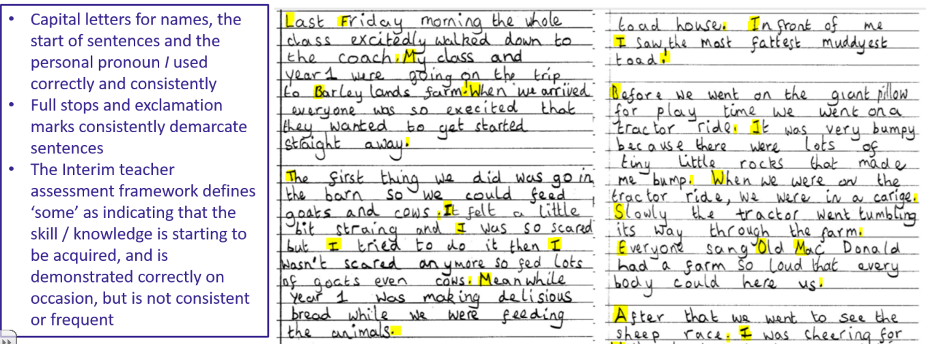

Handwriting and Letter Formation Guide.
Please use the following guide when supporting your child at home with their writing.

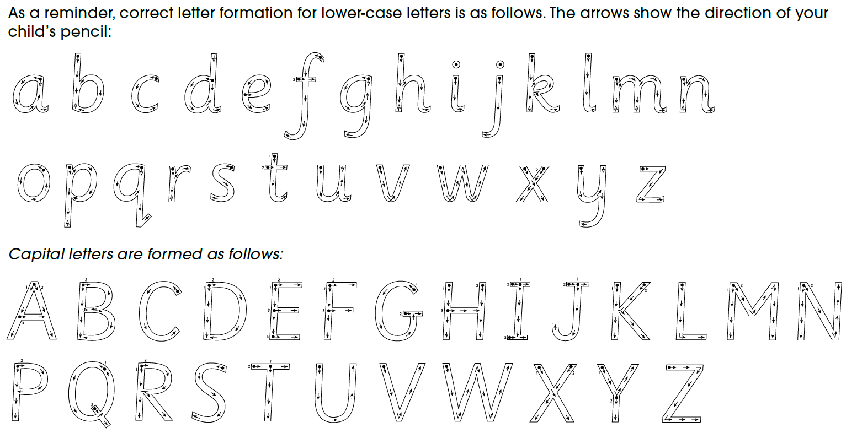

Maths
The principal focus of mathematics teaching in Key Stage 1 is to ensure that pupils develop confidence and mental fluency with whole numbers, counting and place value. This should involve working with numerals, words and the four operations (addition, subtraction, multiplication and division), including practical resources (for example, concrete objects and measuring tools
At this stage pupils should develop their ability to recognise, describe, draw and compare and sort different shapes and use the related vocabulary. Teaching should also involve using a range of measures to describe and compare different quantities such as length, mass, capacity/volume, time and money.
By the end of Year 2, pupils should know the number bonds to 20 and be precise in using and understanding place value.
Pupils should read and spell mathematical vocabulary.
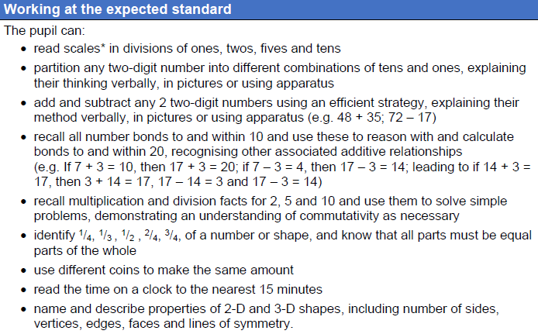

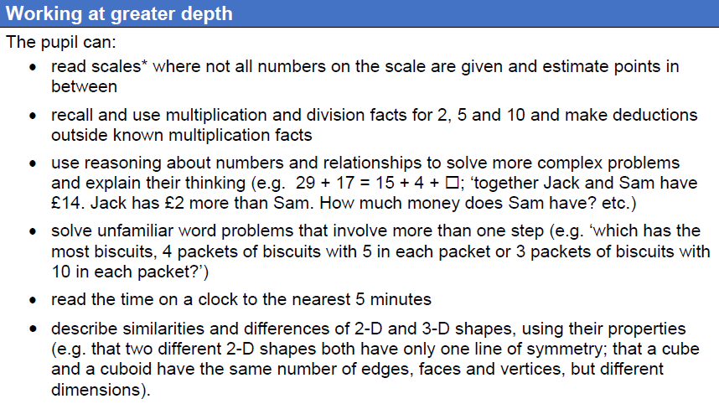

Below are some examples of the methods we use in class for the different areas taught in Maths. These will be beneficial when supporting your child at home, as using the same method taught in school will aid their understanding and consolidate current learning.
Number and place value
Addition

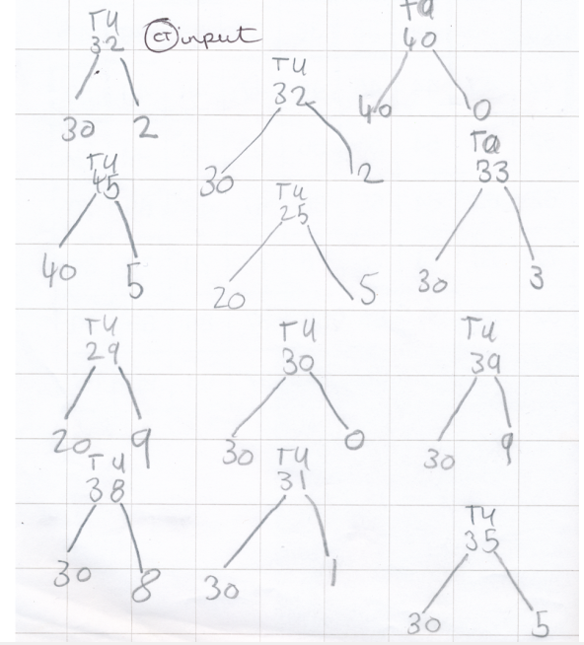
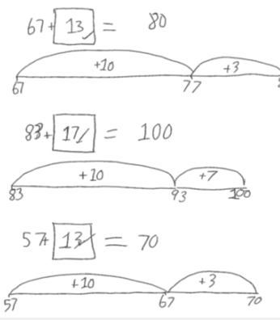

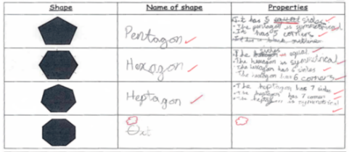
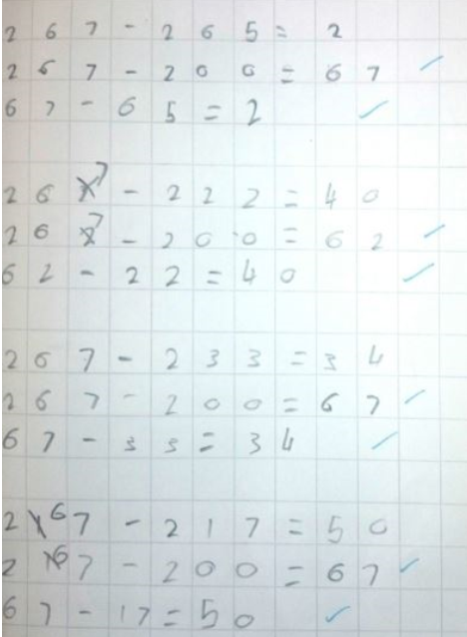
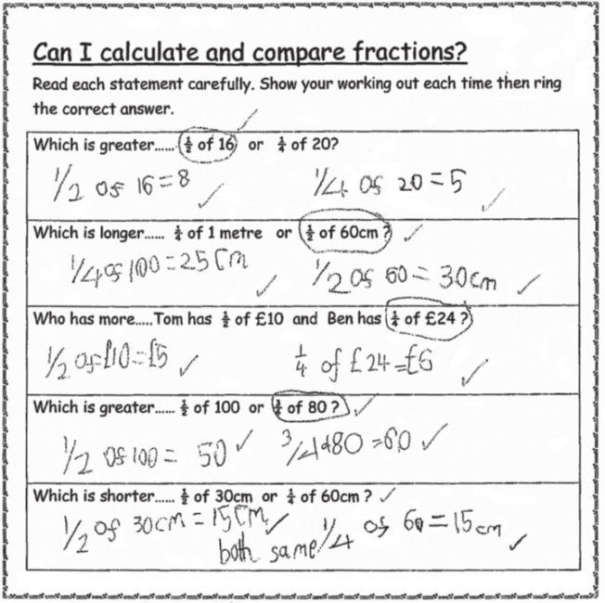
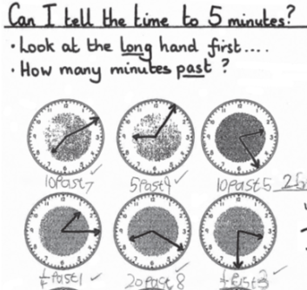
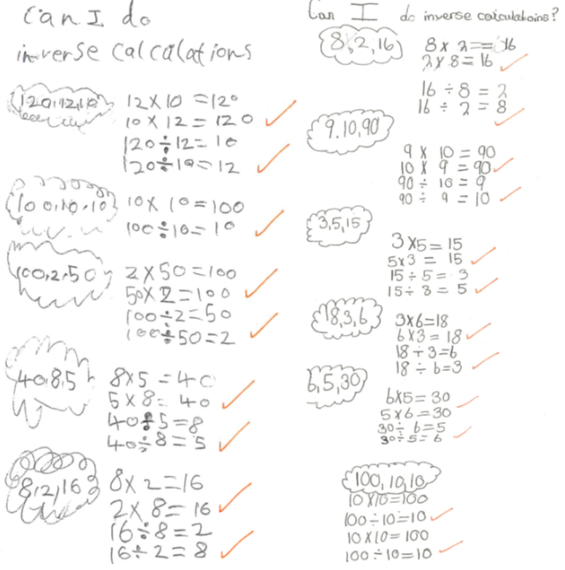
Subtraction
Multiplication and Division
Fractions
Measure
Geometry

